American International University – Bangladesh

Department of Computer Science & Engineering



### Project Title: Apply data preparation steps (which can be applied) and do the univariate data exploration for the given dataset (Titanic – modified).

|  |  |
| --- | --- |
| **Submitted by-** | **Submitted to-** |
| **Name: Md. Shohaibur Rahman**  **ID: 20-42424-1**  **Section: C**  **Summer 2022-2023 B.Sc. CSE** | **Name: DR. ABDUS SALAM** |

# Dataset Description:

The Titanic dataset is a comprehensive dataset that provides information about passengers on board the RMS Titanic. It consists of data related to 891 passengers. But for this project we will use dataset from 250 passengers includes various attributes such as their gender, age, sibling, parch, ticket fare, embarked, class, survival status etc. The dataset offers insights into the passengers' demographics, ticket details, and important factors that may have influenced their survival. The target variable, "Survived," indicates whether a passenger survived the Titanic disaster or not. This dataset serves as a valuable resource for analyzing and understanding the demographics and factors associated with the survival of passengers on the Titanic.

# Attributes:

1. Gender: The gender of the passenger, classified as male or female.
2. Age: The age of the passenger in years.
3. SibSp: The number of siblings or spouses the passenger had aboard the Titanic.
4. Parch: The number of parents or children the passenger had aboard the Titanic.
5. Fare: The fare or ticket price paid by the passenger.
6. Embarked: The port of embarkation for the passenger, classified as C (Cherbourg), Q (Queenstown), or S (Southampton).
7. Class: The passenger class, indicating their socio-economic status, classified as 1 (First class), 2 (Second class), or 3 (Third class).
8. Who: Indicates whether the passenger is an adult or a child.
9. Alone: Specifies if the passenger was traveling alone or with family members, classified as yes or no.
10. Survived: Indicates whether the passenger survived the Titanic disaster or not, classified as 0 (No) or 1 (Yes).

Purpose: The Titanic dataset aims to analyze the factors influencing passenger survival aboard the Titanic. It provides information on attributes such as gender, age, family relations, fare, embark, class, and survival status. The Titanic dataset enables the exploration of patterns and insights to understand the demographic and situational factors associated with higher chances of surviving the tragic Titanic event.

# Project Overview:

Data pre-processing plays a critical role in data analysis by transforming raw data into a structured format suitable for analysis by computers and machine learning algorithms. Raw data often contains errors and inconsistencies that need to be addressed before it can be effectively utilized. Additionally, univariate exploration focuses on analyzing individual variables within a dataset, without considering their interrelationships. In the given dataset, it is evident that data cleaning and pre-processing are necessary before proceeding with any analysis. By performing these steps, we can ensure that the dataset is prepared for further analysis and insights can be extracted accurately

# Data pre-processing:

1. **Importing the Dataset:** The dataset is located in a file called Titanic -modified .csv in the current working directory. To begin data pre-processing using R, the first step is to import the dataset. Once imported, the Titanic -modified .csv file is transformed into an R data frame and stored in a variable named "Titanic". After printing the dataset, it looks like this-

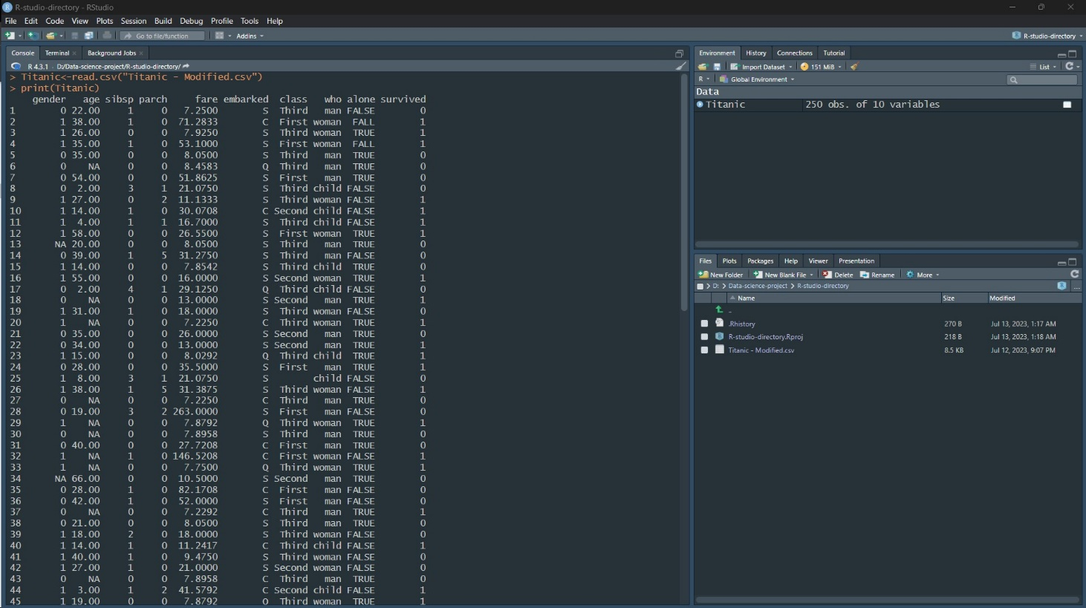

## Dealing with Missing Values:

* 1. We can see from the dataset that, there is some missing value (NA) and blank present in column name- gender[13], age[48], embarked[1], and class[4]. We can find out the missing values in this way:

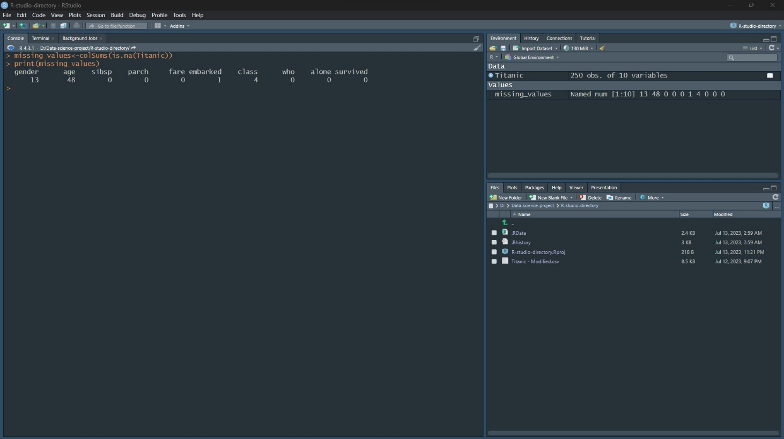

Before, the dataset looked like this-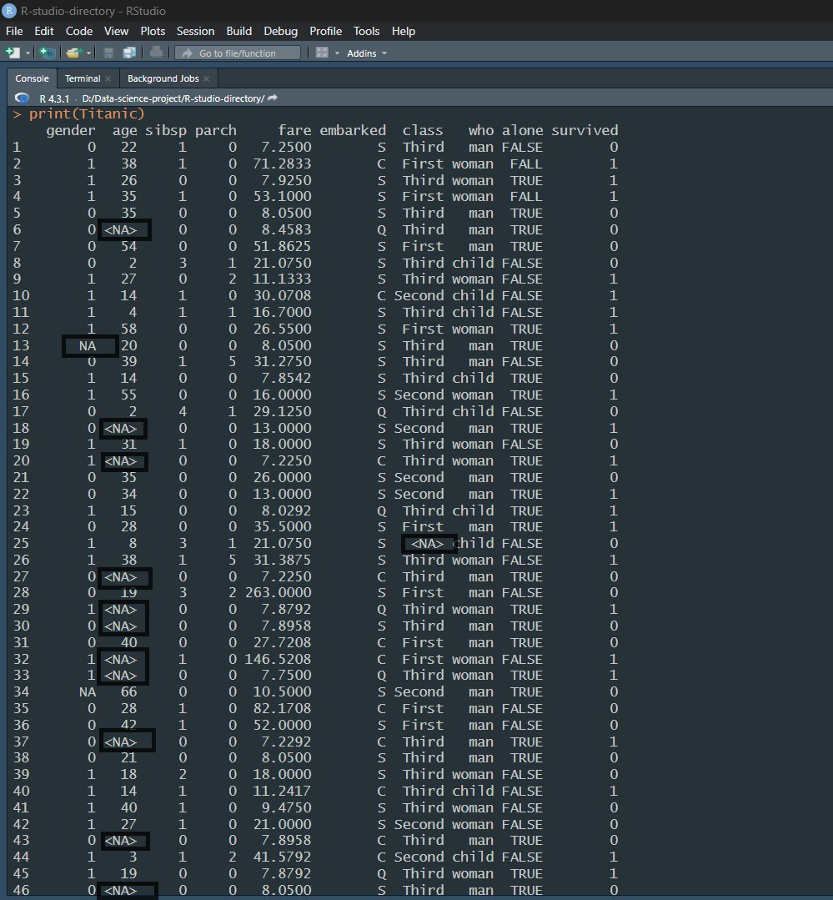

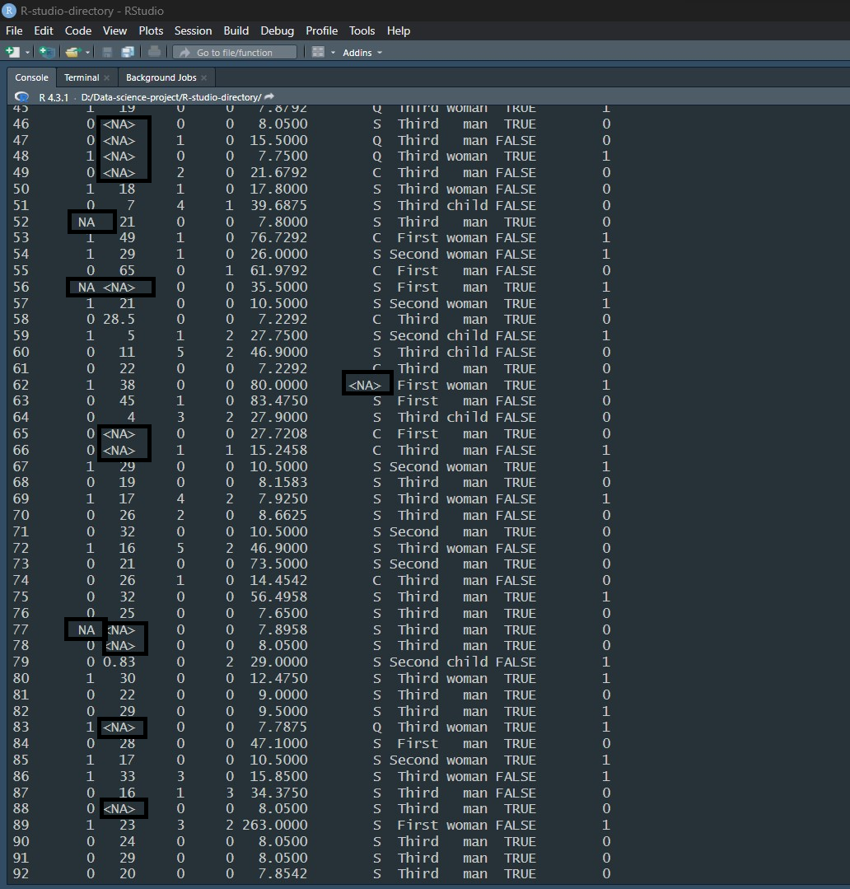

* 1. Now, as “gender” and “age” columns are in the numerical format we can replace the missing value with the “mean value” of those columns. R code for replacing missing value by the mean, Now, the dataset looks like this-

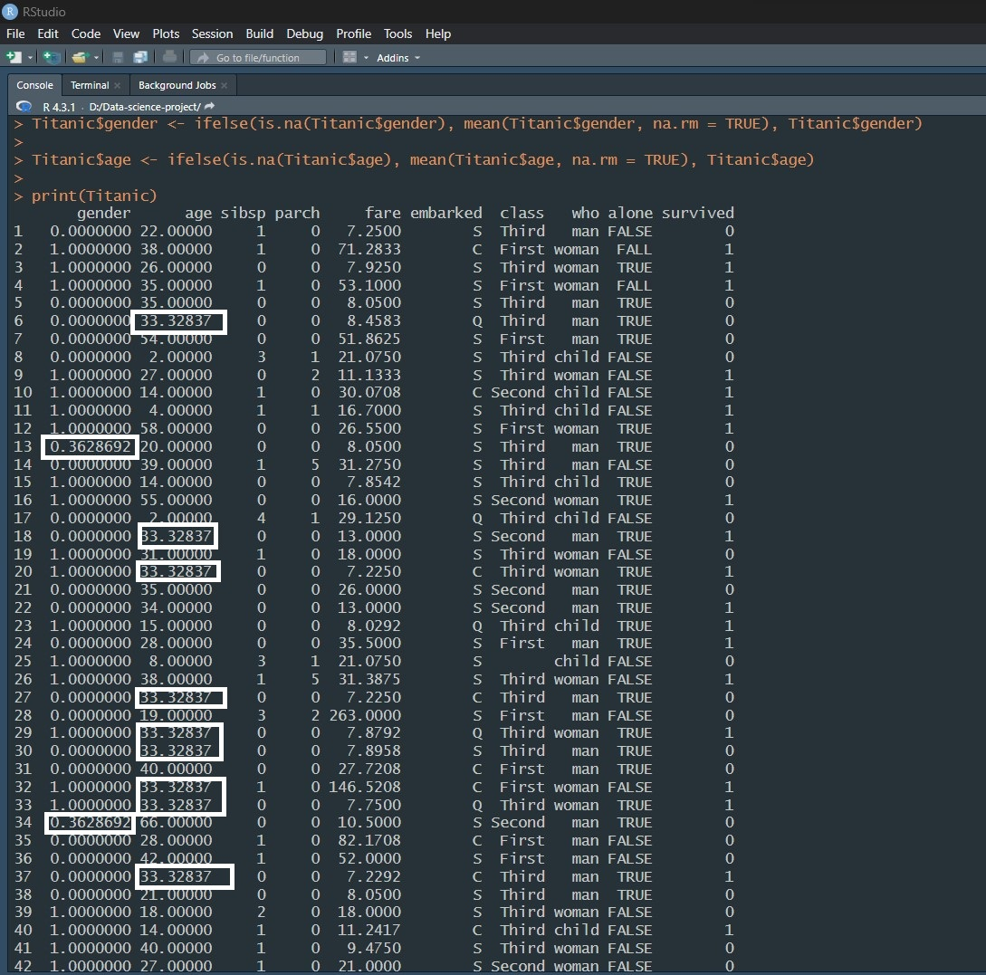

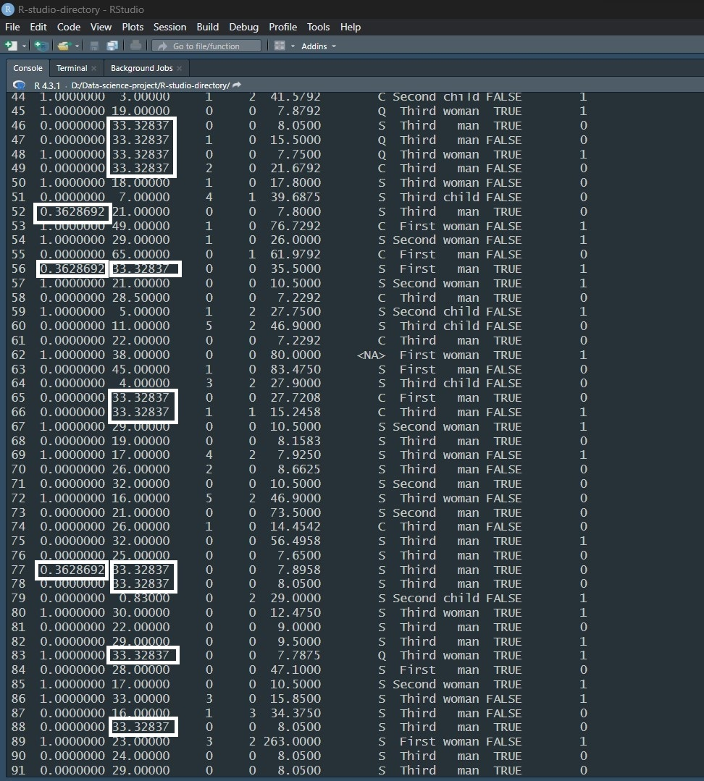

* 1. Here we can see that in the “embarked” and “class” column, some values are missing. 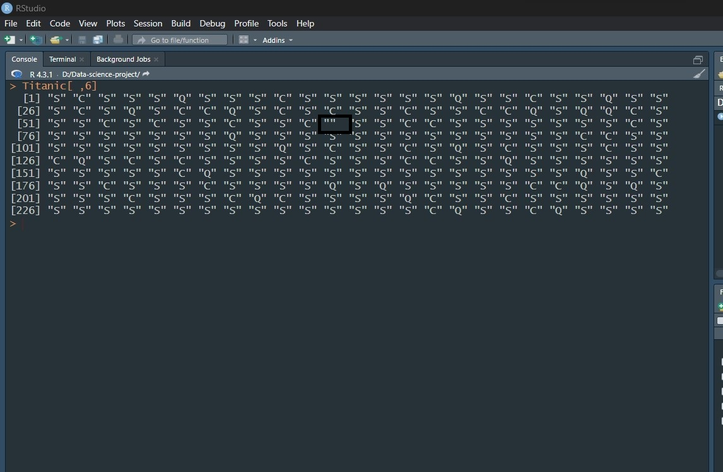

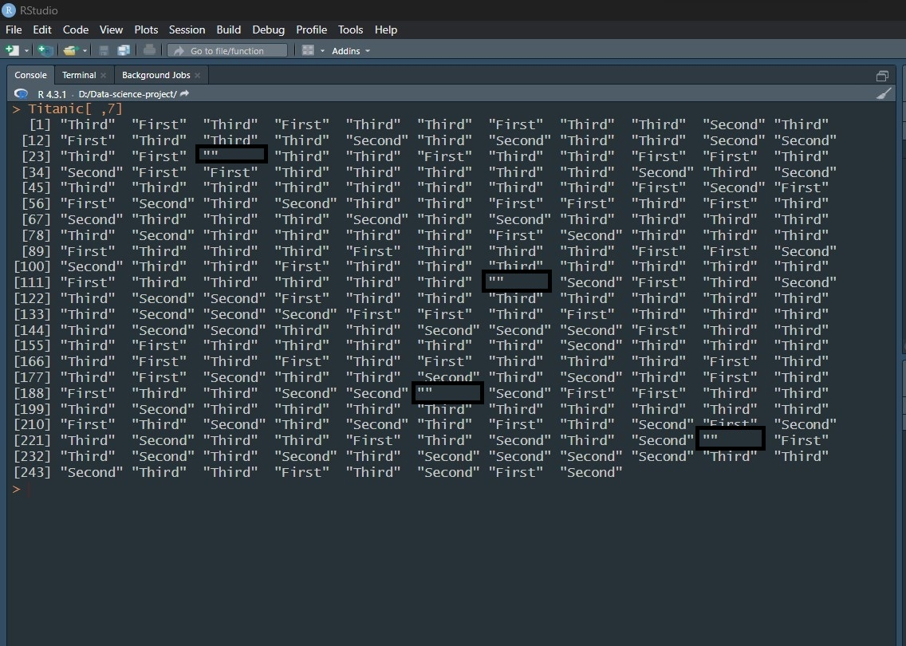

As the values are not numeric but “string”, we can solve the issue by putting the most common value of the column this way-

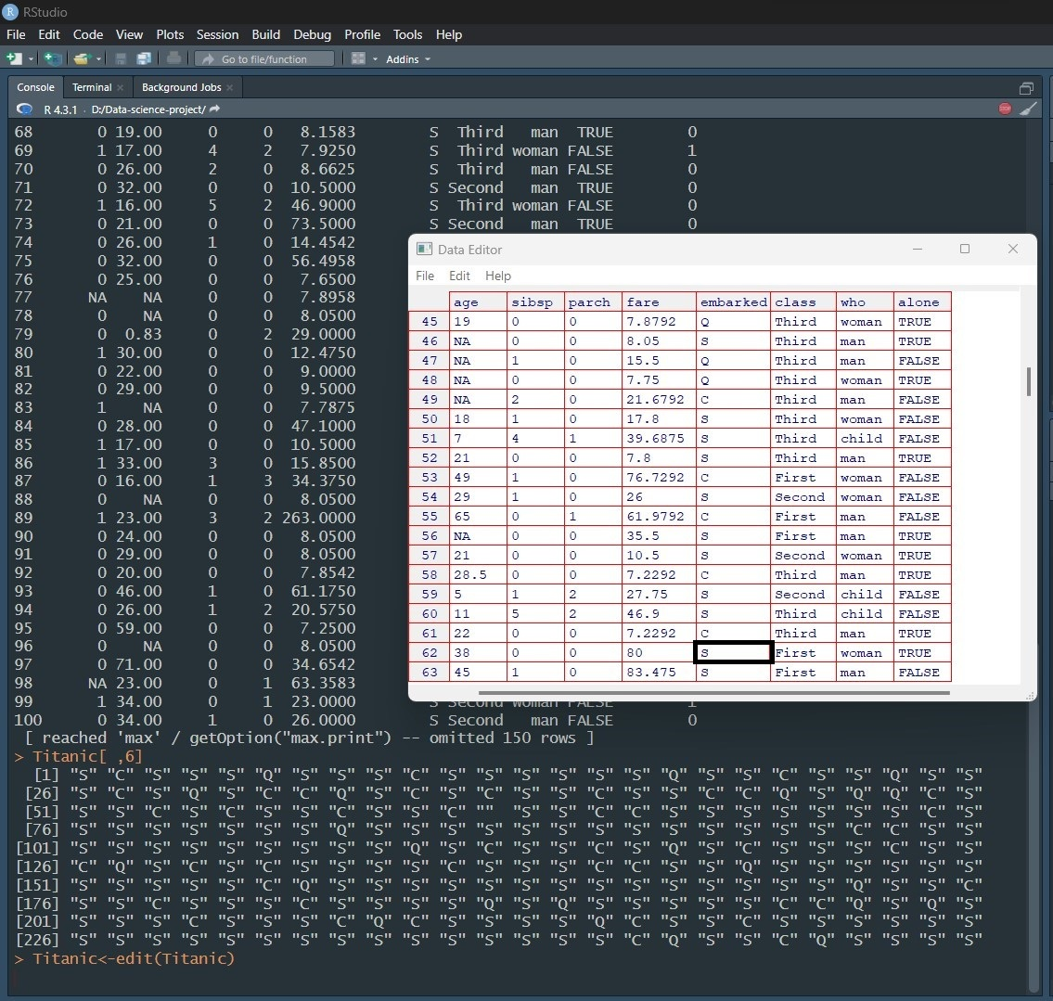

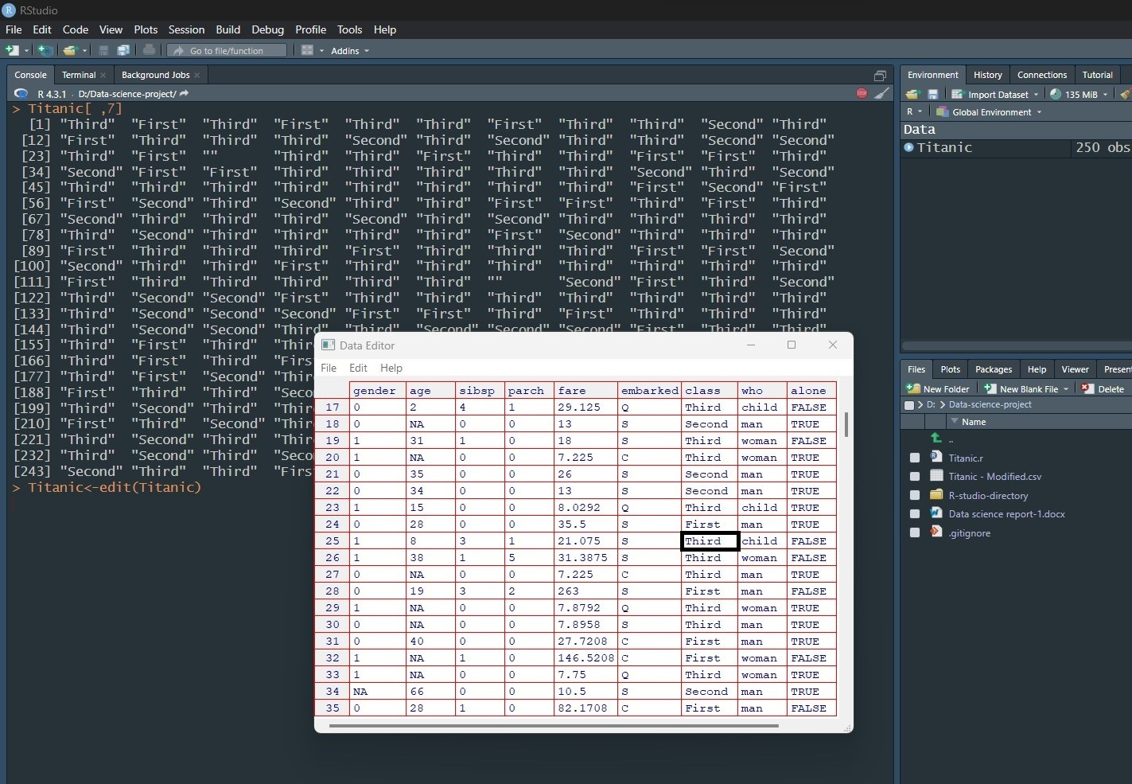

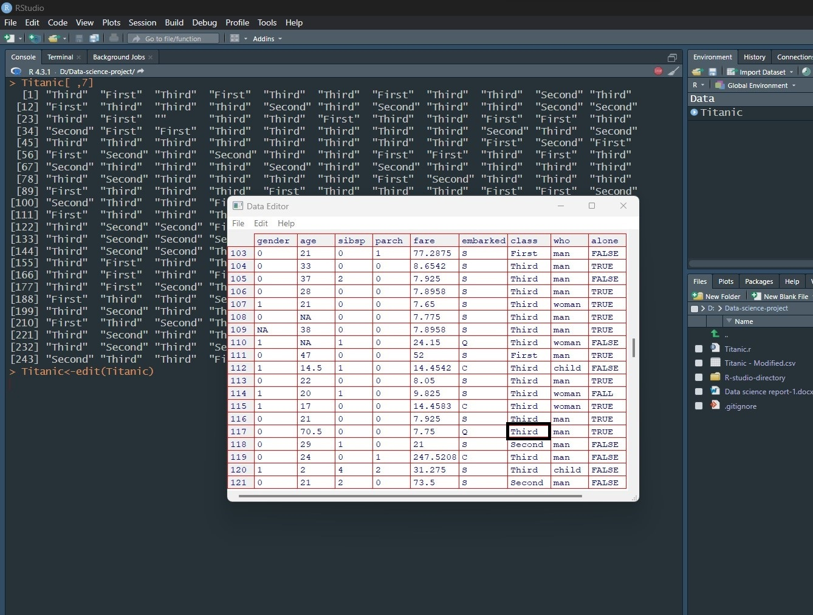

## Dealing with Data types and Conversion:

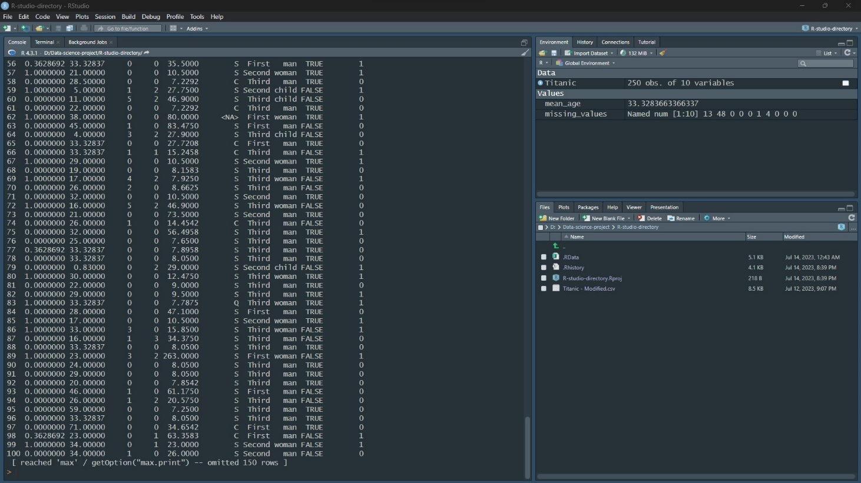

Now we can see that the maximum column contains decimal places in the data after dealing with null values in those columns. As we are not interested in having decimal places for those columns, we will round it up.

We can round those variables in this way-

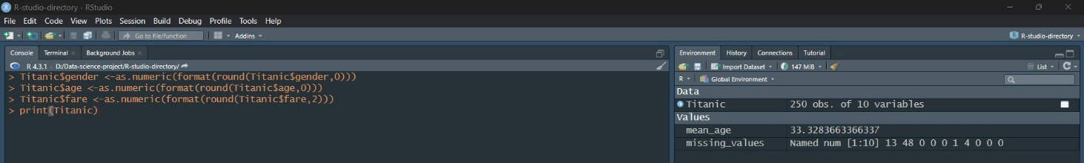

Datset with round figure-

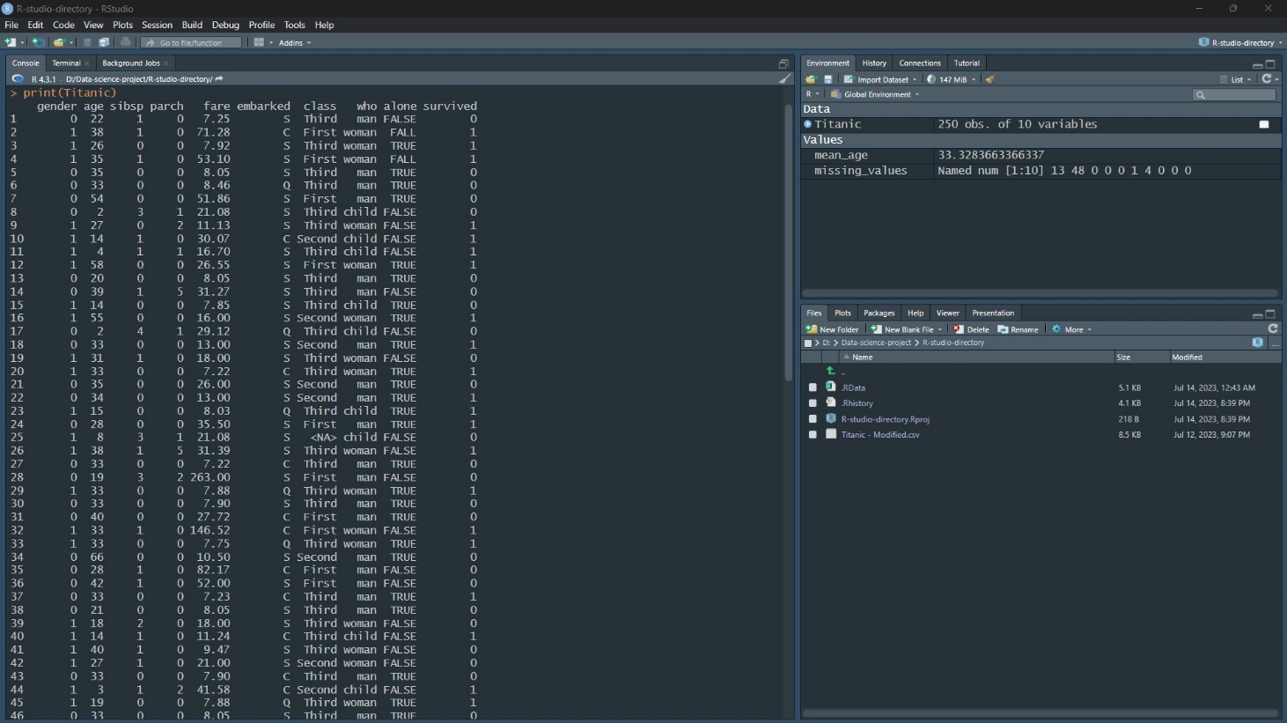

## Dealing with Outliers:

Here, we can check whether there are any outliers or not. So, to find it out we can use this way-

**R code-**

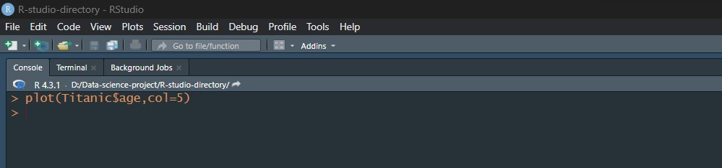

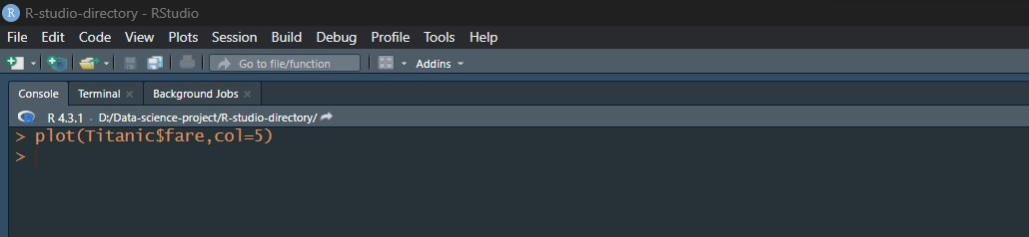

**Output-**

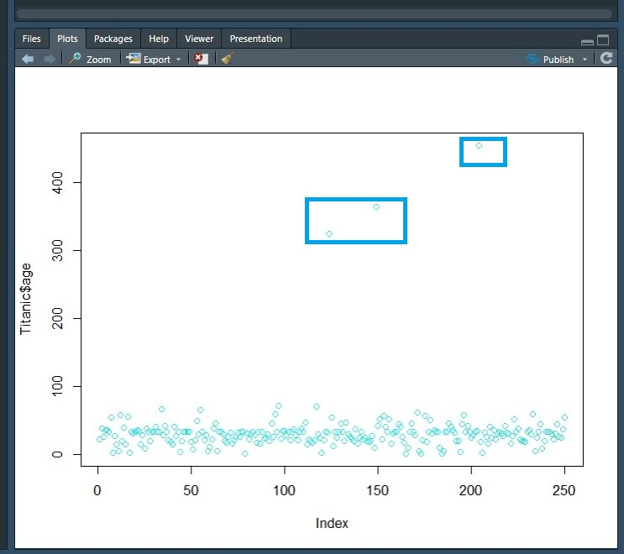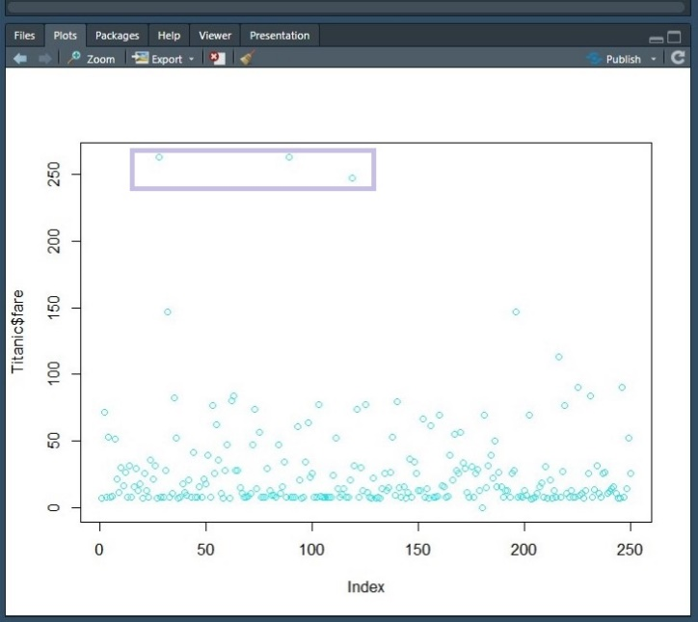

So, here we can see that in column $age and $fare , there are three points or data which are quite different from the rest of the points. So, this can be called Outliers.

But for other attributes- $parch and $sibsp we didn’t find any outliers because some values may not usual compared to most but those result can be possible.

Given below-

**R code-**

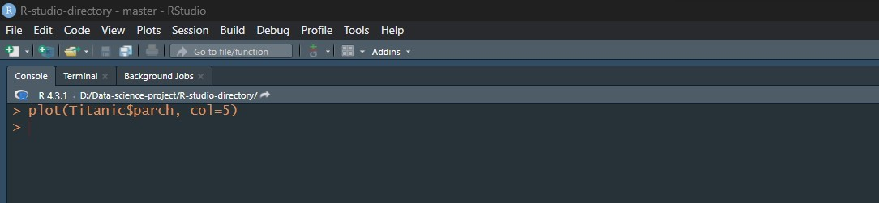

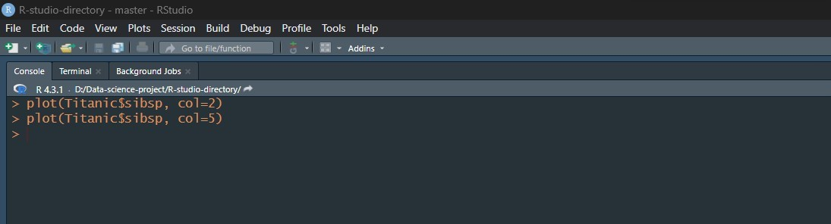

**Output-**

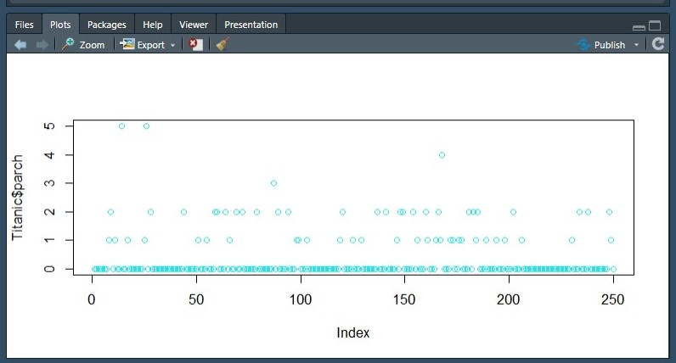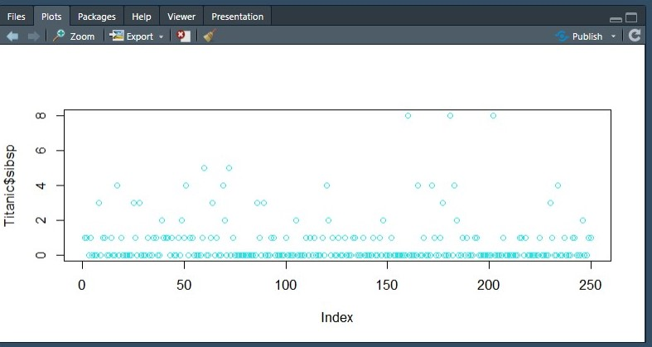

# Representation of Data:

# Using barplot we can evaluate some insights from dataset such as-

**R code-**

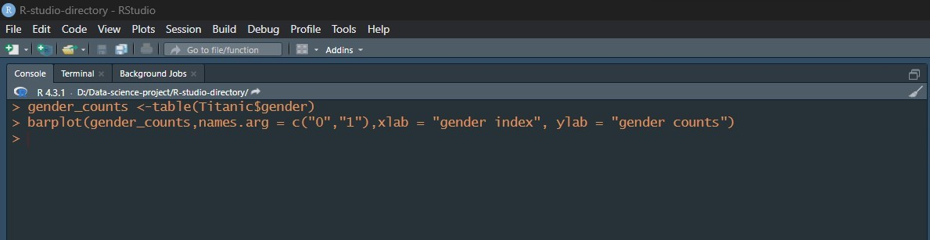

**Output-**

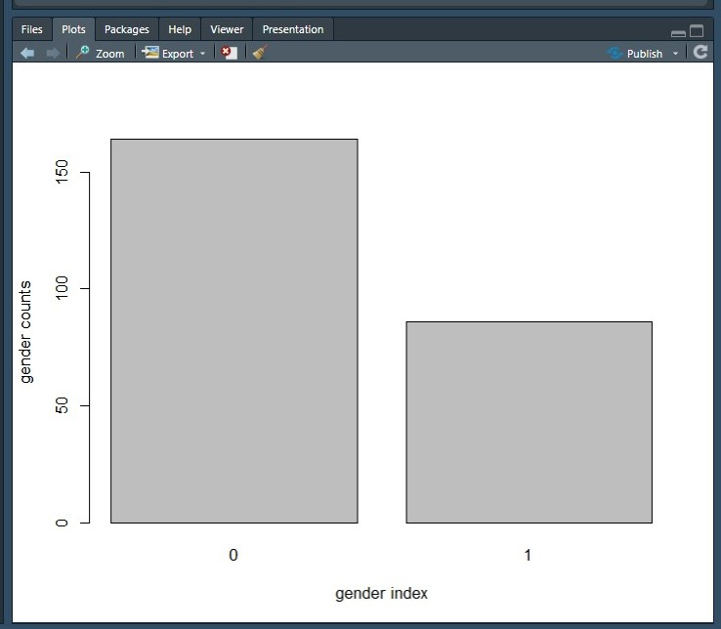

Here “0” represents male and “1” female in genders , from which we can extract above 150 amongst the passenger were male and below 100 but above 50 were female amongst 250 passengers dataset.

Using this method we can get barplot and can discuss what it represent for other attributes as well.

Barplot for parch -

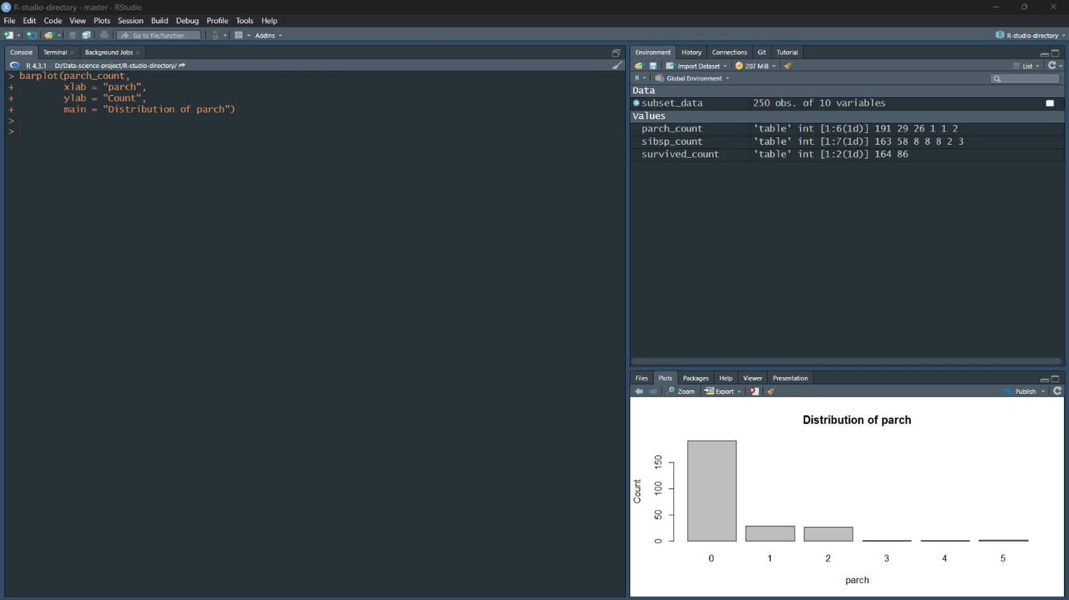

From the barplot, we see more than 150 passengers had not any parents or children amongst the 250 passenger dataset. Less than 50 passenger had 1 and 2 parents or children. Less than 50 passengers had from 3 up-to 5 parents and children which might represent with passengers whole family.

Barplot for sibling-spouse(sibsp)-

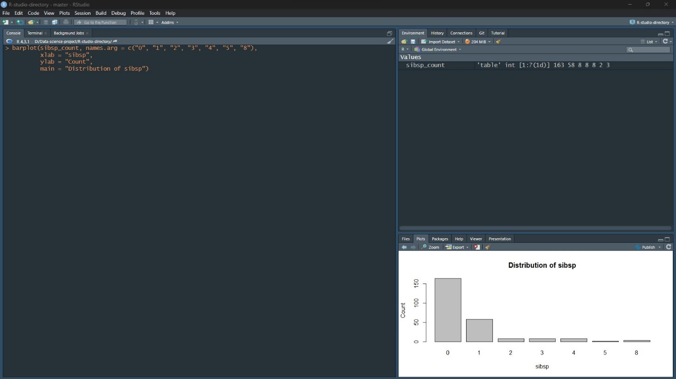 From the barplot, we see more than 150 passengers had not any siblings or spouse amongst the 250 passenger dataset. Around 50 passenger had 1 sibling or spouse. Less than 50 passengers had from 2 up-to 8 siblings and spouse.

Barplot for survived-

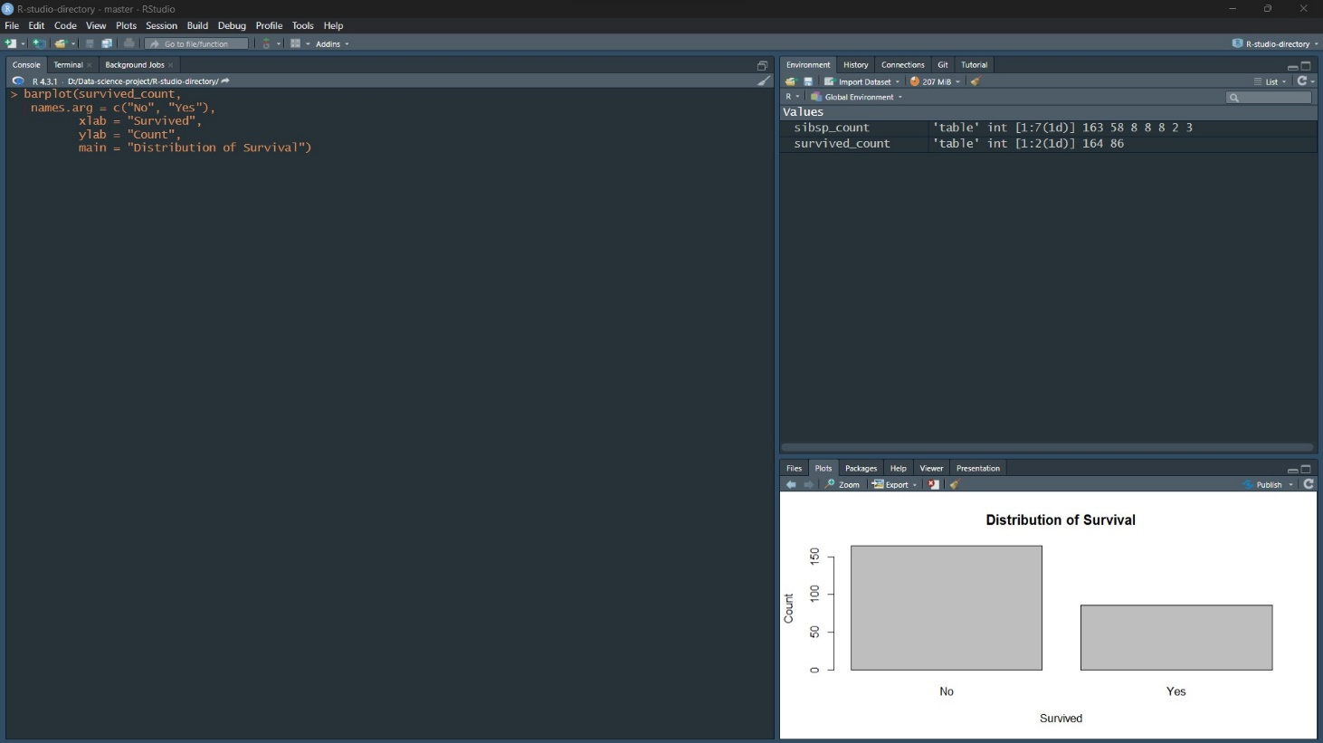

From the barplot, we see around more than 50 and less than 100 passengers have survived but the not survival rate is higher than 150 passengers amongst the given 250 passengers dataset.

# Univariate data exploration:

Univariate exploration in data science involves analyzing individual variables in a dataset one at a time, without considering the relationship between variables. This type of analysis is useful for gaining a basic understanding of the distribution, central tendency, and variability of a variable.

1. So, here we can find out the exploration of the given attribute-

For “gender” attribute

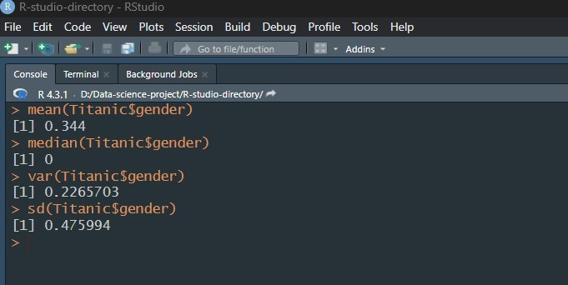

For “age” attribute

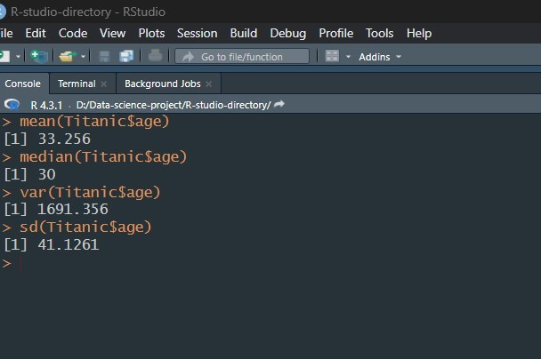

For “sibsp” attribute

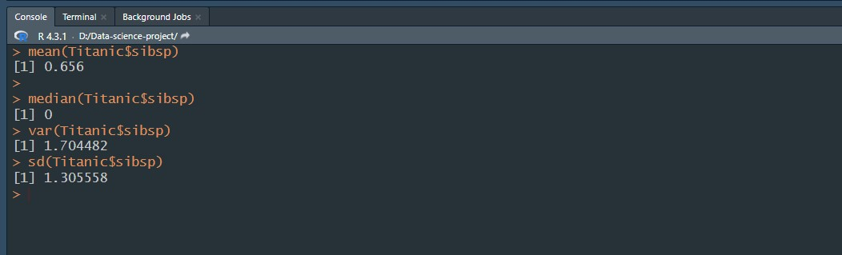

For “parch” attribute

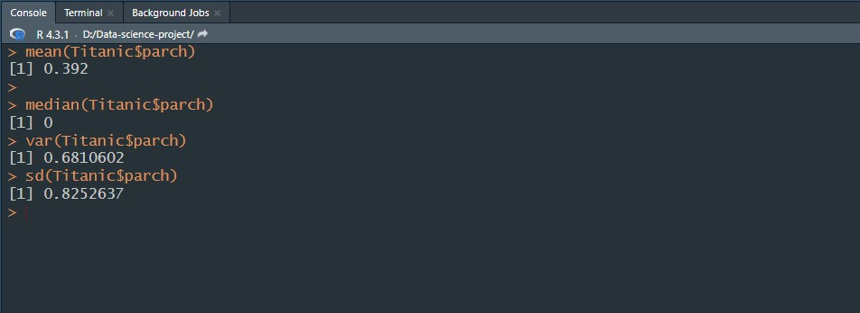

For “fare” attribute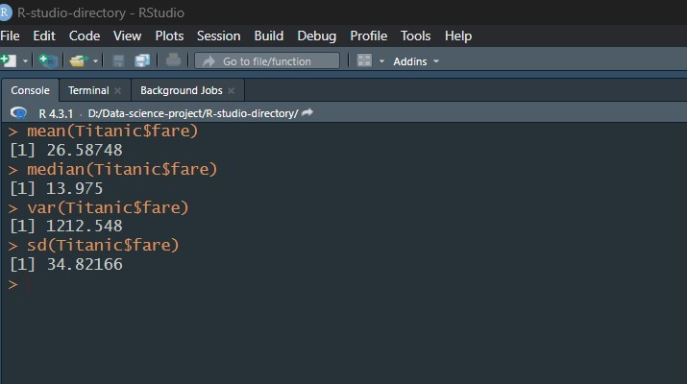

For “survived” attribute

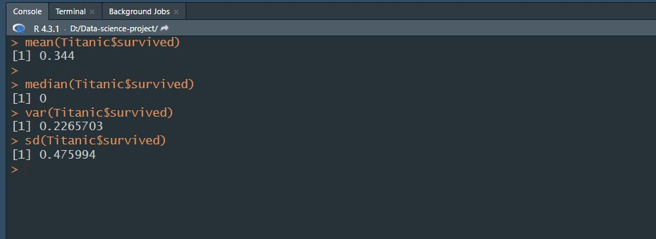

So we can summarize from above attributes-

|  |  |  |  |  |  |
| --- | --- | --- | --- | --- | --- |
| Attributes | Gender | Age | fare | parch | survived |
| Mean | 0.344 | 33.256 | 26.587 | 0.392 | 0.344 |
| Median | 0 | 30 | 13.975 | 0 | 0 |
| Variance | 0.226 | 1691.365 | 1212.548 | 0.6841 | 0.226 |
| Standard deviation | 0.476 | 41.126 | 34.821 | 0.825 | 0.476 |

1. Standard deviation of each attribute (gender, age, sibsp, parch, fare & survived)

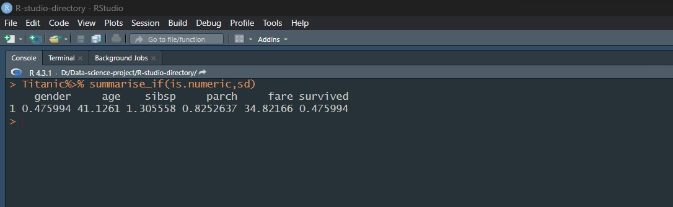

Here, we calculated the standard deviation of each numerical attribute.

# Discussion & Conclusion:

At the beginning of the project, we were given a dataset that was totally messy. Null values, missing values, and outliers were present in this dataset. The dataset was like this-



After Applying data preparation steps and the univariate data exploration for the given data set., we got the dataset looks like this-



Now, we can use this clean, pre-processed dataset for further use.